A REPORT OF 8 WEEKS OF INDUSTRIAL TRAINING

at

Indian Institute of Technology (IIT)

SUBMITTED IN PARTIAL FULFILLMENT OF THE REQUIREMENT FOR THE

AWARD OF THE DEGREE OF

**BACHELOR OF ENGINEERING**

Computer Science and Engineering



JULY-AUGUST-2022

**SUBMITTED BY:**

NAME:-Abdul Rehman

REG.NO:-GCS/2040305

DEPARTMENT OF COMPUTER SCIENCE AND ENGINEERING

SANT LONGOWAL INSTITUTE OF ENGINEERING AND TECHNOLOGY

**SANT LONGOWAL INSTITUTE OF ENGINEERING AND TECHNOLOGY**

**CANDIDATE’S DECLARATION**

I Masoom Mittal hereby declare that I have undertaken 8 weeks Industrial training at Indian Institute of Technology (IIT Roorkee) during a period from 6 July,2022 to 1 Aug,2022 in partial fulfillment of requirements for the award of degree of B.E(Computer Science and Engineering) at SANT LONGOWAL INSTITUTE OF ENGINEERING AND TECHNOLOGY, LONGOWAL. The work which is being presented in the training report submitted to Department of Computer Science and Engineering at SANT LONGOWAL INSTITUTE OF ENGINEERING AND TECHNOLOGY, LONGOWAL is an authentic record of training work.

Signature of student

**Abstract**

Industrial training is an important phase of a student life. A well planned, properly executed and evaluated industrial training helps a lot in developing a professional attitude. It develops an awareness of industrial approach to problem solving, based on a broad understanding of process and mode of operation of organization. After undergoing 8 weeks training in Indian Institute of Technology (IIT Roorkee), I learnt various aspects of ML (Machine Learning ) and implemented on real problem of determining flooded areas using SAR images and was able to extract area of flooded region. I had great time learning about aspacts and applications of machine learning.

**Acknowledgment**

I would like to express my deepest appreciation to all those who provided me the possibility to complete this report and training. A special gratitude I would like to give to my training instructor Dr. Alok Bharadwaj who helped me with my paper and all work of reseach internship and all the required concepts in a very professional and easy to learn manner. He provided me and many other students proper doubt assistance and this helped me to rectify my mistakes and clear my doubts in some concepts.

Lastly I would like to thank Dr Manminder Singh Sir, to encourage us for training and providing guidance regarding choosing industry and clearing our doubts by organizing a google meet session.

**CHAPTER-1 INTRODUCTION TO INSTITUTE**

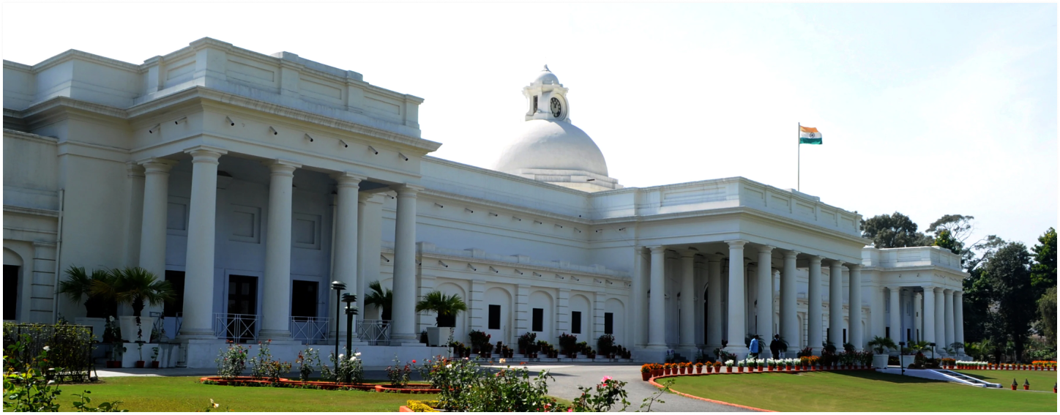

National Institute Ranking Framework, NIRF Rankings 2022 Architecture have been released online today, on July 15, 2022. This time again, Indian Institute of Technology, IIT Roorkee has come at the top spot, Rank 1 as the Top Architecture College of the country. This is followed by National Institute of Technology, NIT Calicut at spot 2. Check complete list here and on nirfindia.org.

To mark 175 years of the establishment of Indian Institute of Technology (IIT), Roorkee, the central government will issue a Rs 175 coin, according to a gazette notification by the Union finance ministry which happened late last month. While the notification didn't specify any date, it is expected that the coin will be released on November 25, when the institute celebrates its Foundation Day.

The Indian Institute of Technology (IIT) Roorkee’s team of researchers led by Professor Dharmendra Singh has won the National “Gold” Award for e-governance for outstanding research on citizen-centric services by academic or research Institutions. The team has won this award for the development of e-waste-based microwave absorbing material for electromagnetic shielding and stealth applications.

Indian Institute of Technology Roorkee has been ranked #5 in the Atal Ranking of Institutions on Innovation Achievements (ARIIA) by the Ministry of Education, Government of India. IIT Roorkee has improved four places from its last year’s rank. Dr. Subhas Sarkar, Hon’ble Minister of State for Education, Government of India, announced the results today (29th December 2021). As many as 1,438 Higher Education Institutions (HEIs) (including all IITs, NITs, and IISc, among others) participated in the Third Edition of ARIIA Rankings as compared to 674 HEIs during last year.

The Indian Institute of Technology (IIT Roorkee) has been awarded the top position under the most innovative research institutions category by the Confederation of Indian Industry (CII). The institute was selected for the award for the following innovations- Visco-elastic Energy Dissipating Link Elements for Earthquake resistant housing construction, Nitrogen-Doped Reduced Graphene Oxide (N-rGO) for High-Performance Supercapacitor, Nitrogen-Doped Reduced Graphene Oxide (N-rGO) for High-Performance Supercapacitor.

**CHAPTER-2 Research Motivation and Introduction**

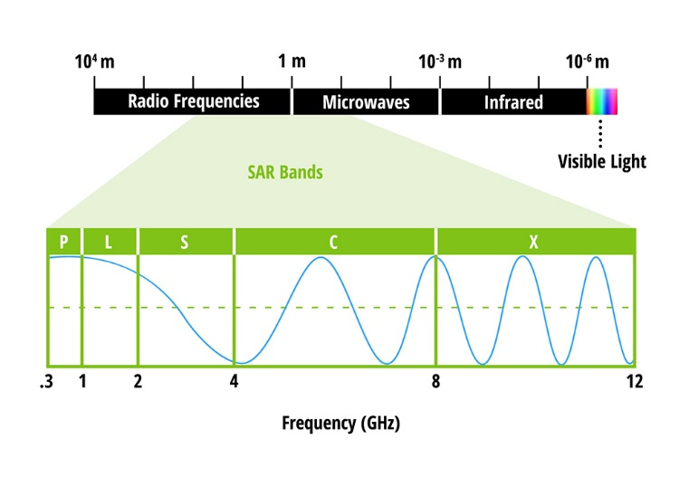

• Synthetic Aperture Radar (SAR) is an all-weather, day-and-night satellite observation technique to observe the earth’s surface processes.

• Flood is considered to be one of the major disasters causing huge losses to life and property across the globe. In particular, floods occur in different parts of India every year during the monsoon season. • Our motivation in this work is to use SAR to identify flood extents and to assist in emergency response operations. SAR is a useful tool for flood detection as it is operational during cloud cover and rainfall to give information on flood extents.

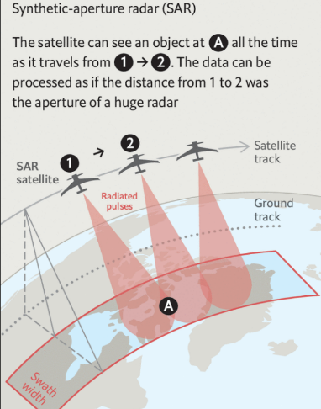

Study Area and Data

* We have selected two flood extents representative of the flooding situation in urban and semi-urban areas. A major reason to select the two events is that SAR images were acquired within a few hours of the flood events.
* The first flood event occurred due to Hurricane Matthew on 8 October 2016 Hurricane Matthew in the Lumberton, North Carolina region of USA.
* The second flood event occurred in Phitsanulok, which is a semi-urban area in Thailand on 13 October 2017. Phitsanulok is exposed to floods each year. The SAR image of the flood event is shown in Figure 3(b).
* 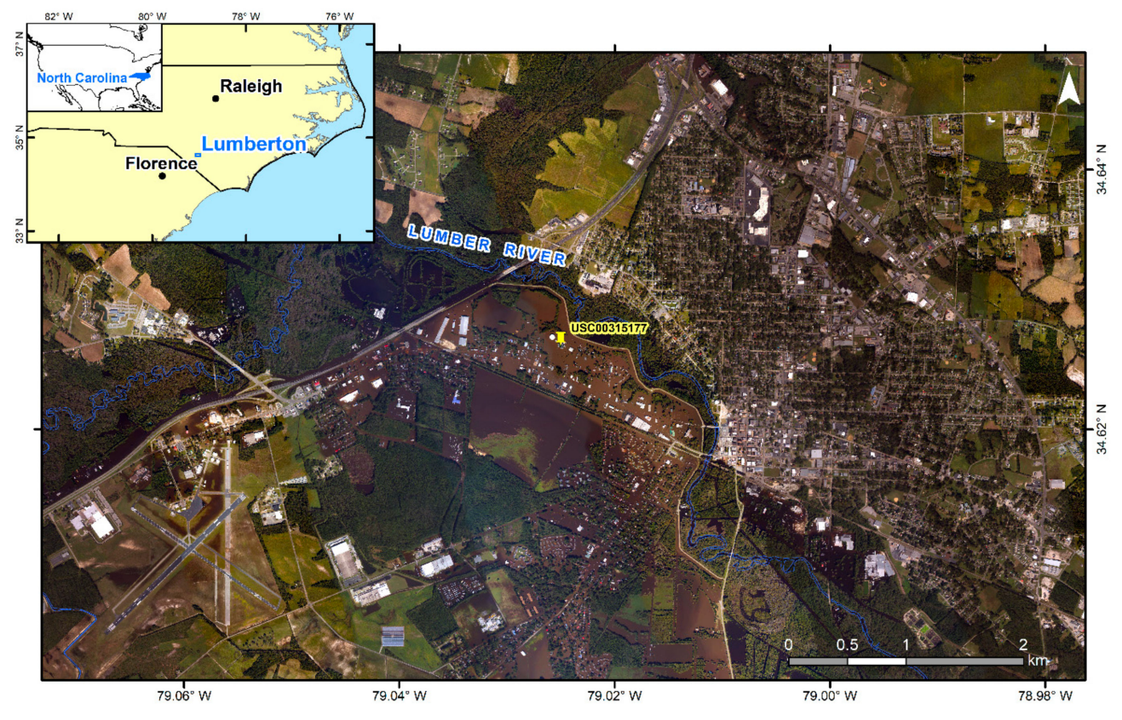For both study areas, we have selected SAR images from the SENTINEL-1 satellite operated by European Space Agency Satellite.

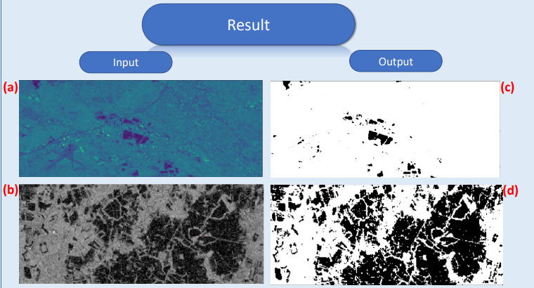

**Conclusions and Future Work:**

* Flood extents are detected successfully in single SAR images. Our approach can be used in real-time to detect flood extents. This information is critical for first responders to plan aid kits, tents, etc. Future Work.
* We have not performed an accuracy assessment on the extracted flood extents in terms of generation confusion matrix and accuracy assessment metrics. This will be completed in near future.